Test Look At Me

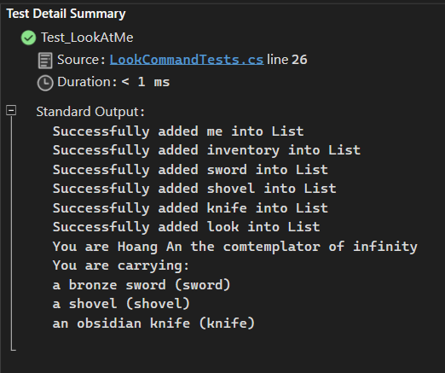

Test Look At Gem

Test Look At Unk

Test Look at Gem in No Bag

Test Look at No Gem in Bag

Test Invalid Look

